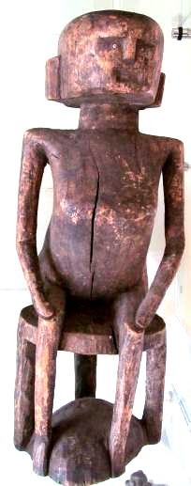```Afr-Mali-Dogon-Nyerum-Female Water Spirit on a Stool

*Nyerum*, Female Dogon Water Spirit, on a Wooden Stool, Mali, mid-late 19th century

This carved, wooden figure of *Nyerum* is seated on a stool that consists of two discs, the upper one, the seat, represents the sky, and the other, the platform, the earth. Sky and earth are connected by three supporting posts metaphorically symbolizing *Nommo*, who controls the water in wells. The plain posts represent aniconic figures of Nommo. On other stools the stool supports are carved male figures. *Nyerum* claims her authority over her male counterpart as protectress of the community by having him support her, which is symbolized by *Nommo* being the legs of her stool. In Dogon society stools are considered to be objects of prestige that defined social status. This figure of *Nyerum* would have been placed in a shrine to whom prayers were made in order to insure the well-being of the community through their access to an adequate supply of potable water.

*Nyerum* is a mythical, primordial, female water-deity of the Dogon from Mande on the Bandiagara Cliff in western Mali, that has given its name to a family of West African languages, Mandingo. Dogon cosmology linked collective identities, native cults and systems of authority to water control and its sustainability, on which communal life depended. Control of water was simultaneously social, by which the right to access certain sacred wells was restricted, political by which power élites managed water resources, and ritualistic by which shamans organized and conducted rites of rainmaking and annual purifying offerings and sacrifices to insure an adequate water supply for the new year. It is believed that wells are inhabited by two invisible beings to whom sacrifices must be made. These spirits are called *Nyerum,* who controls people, and *Nommo* who controls water.

*Nyerum* resides not in the water, nor in the well itself, but at the 'mouth' of the well, and she must be appeased with appropriate offerings and sacrifices, for if she is angered, she may drag a person into the well to be drowned. Notice that her visage portrayed in this wooden figure has a stern, inscrutable, implacable stare, enhanced by the small pupils of her eyes fashioned from tiny metal plugs. In one of the stories about *Nyerum*, an elder says, 'If you stay three days without drinking [water] you will die... . For *Nommo* and *Nyerum* we make offerings to ask them to give water... . Last year, the well in our village ate our child, so we made sacrifices for all the things that were inside the well' (Boujou 2003).

One elder from Mali explained that "Where rites have been forgotten, the water is scarce and therefore there is no life" (Boujou 2003). *Nyerum's* role is precisely to insure that the rites will be performed according to tradition and on schedule, hence her harsh demeanor. *Nyerum's* role is to insure that *Nommo* will leave the sky and descend to earth on rainbow's path. On earth he becomes a water spirit and makes the water "strong" and abundant. There are still some Dogon communities that claim *Nommo* as their ancestor, and call him *Binu*. This tradition comes from the primeval Dogon myth of the world before the appearance of death. Since elders were becoming too old, they would change themselves into a large water being, a python or a crocodile, and dwell in ponds and rivers, beginning a new life as a water spirit called *Nommo*, helping maintain the source of water for their descendants. These water spirits (*Nommo*) were, in fact, considered to be the ancestors of the autochthonous people still living in the area and were called "Binu" as a personal, familial nick-name, because they were, in fact, part of their family.

References:

Griaule, Marcel. 1948. *Dieu de l'eau.* Paris: Fayard.

Bouju, Jacky. 2003. The spirit of water: in the Dogon world, *Leonardo* (MIT Press)*,* 36(4): 279-280.